Chapter x

Twitter Sentiment Classification: Hybrid Models and BERTweet Hybrid Models with SHAP Explainability
Mahi Agrawal¹, Mayank Namdev²
^{1,2}Department of Computer Science and Engineering, Manipal University Jaipur, Jaipur, India

Abstract
In Twitter, the analysis of sentiment is important to understand popular understanding in such fields as politics, healthcare, and finance. However, the informal and disruptive nature of Tweets that are brevity-contained, informal, and sarcasm in nature make it difficult to properly analyze sentiment. This document shows a sentiment analysis framework which evaluates conventional high-tech deep learning approaches, machine learning structures and integrated strategies and a dedicated transformer model based on Twitter data. Traditional models like Logistic Regression, Multinomial Naive Bayes and Support vector Machine were followed by a Long Short-Term Memory. network deep learning model. Two hybrids’ models TF-IDF combined with SVM and Word2Vec combined with LSTM enhanced performance attaining accuracies of 88.6 and 89.3 respectively. To boost performance even more, a BERTweet model that was pretrained on extensive Twitter data was refined for three class sentiment analysis and reached around 91% accuracy. Interpret-able AI employing SHAP was established to offer interpretability at the token level. Findings demonstrate the efficacy of transformer-based sentiment examination.

Keywords: Sentiment Analysis, Twitter Data, BERTweet, Hybrid Models, Explainable Artificial Intelligence, SHAP, Natural Language Processing, Transformer Models.

1. Introduction
Social media sites have emerged as a key channel for conveying thoughts, feelings, and responses to reality happenings. Among these platforms Twitter stands out as a good source of real time textual information and is extensively utilized for analysis in various fields including such as politics, healthcare, economics, finance, and social issues. Despite its useful sentiment analysis on Twitter, it continues to be difficult because of the brevity, casual and loud characteristics of tweets, which frequently contain slang, emojis, abbreviations, and irony creating precision interpretation challenges.
Initial research on Twitter sentiment analysis predominantly depended on lexicon-based approaches and conventional ma chine learning algorithms. Even though these methods are computationally efficient these approaches frequently do not convey contextual meaning and semantic connections inherent in social media text. Due to the presence of bigger Twitter datasets utilized deep learning models such as LSTM networks were developed to represent sequential patterns. Although models based on LSTM have enhanced effectiveness compared to conventional methods, they remained limited in handling long range context and ambiguous expressions commonly found in tweets. To improve these limitations hybrid approaches combining feature-based representations with learning-based models have been explored.TF-IDF combined with Support Vector Machines and LSTM with Word2Vec are evaluated to balance computational efficiency and representation learning while these hybrid models show enhanced effectiveness when compared to traditional methods, they remain insufficient for capturing complex contextual semantics. Recent advances in transformer-based architecture have further improved sentiment analysis through self-attention mechanisms. In particular a transformer model BERTweet pretrained on Twitter data exhibits strong capability in learning tweet specific linguistic patterns. However, despite its high predictive accuracy, model interpretability is lacking. To ad dress unified Twitter sentiment analysis framework this is the solution to problem proposed, which measures traditional, hybrid, and transformer explainable artificial intelligibility as it incorporates based models. SHAP for gence (XAI) to give token-level transparency explanations of predictions of models. In order to provide a summary of the proposed methodology, Fig. 1 shows the steps of the Twitter sentiment analysis framework used in this study. The flow represents the summary of the key steps, such as preprocessing of data, feature extraction, base. BERTweet fine-tuning, sentiment, line and hybrid modseling. SHAP-explainable, prediction, and explainability. view of the overall approach

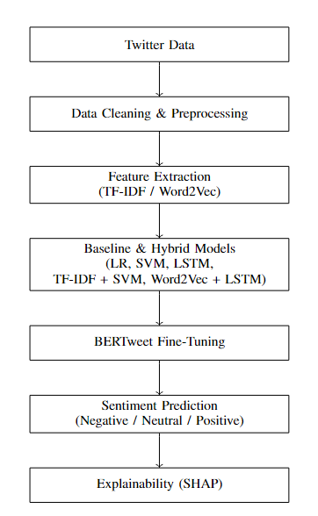
Figure 1. Proposed Twitter sentiment analysis workflow.

2. LITERATURE REVIEW

The sentiment analysis of twitter has increased to play an important role in natural language processing because this platform reflects citizens’ opinion in real time and on large scale. This is in contrast to the conventional sentiment analysis of long documents. Twitter information is not long, formal and very dynamic. Tweets are frequently full of emojis, hashtags, jargon, sarcasm and fast alteration of conversation themes and this renders sentiment interpretable. So, this is challenging and requires special modeling techniques. This influence has made sentiment analysis highly researched on popular opinion, money, medicine and politics. Initial studies mainly depended on lexicon-based and conventional. machine learning methods. Qi and Shabrina [1] demonstrated that these methods fail to retrieve contextual meaning in short and noisy tweets and Hassan et al. [2] revealed that sentiment analysis based on emotions can be used to understand the trends in the cryptocurrency market, but the method is only applicable to limited areas.
As the amount of Twitter data was growing quickly, deep learning models gained popularity. Neelakandan et al. [3] suggested Deep Learning Modified Neural Network (DLMNN) that was assisted with massive preprocessing to enhance the accuracy of sentiment classification. Recent research has been engaged on transformer-based and hybrid architecture to improve contextual knowledge. Al Badani et al. [5] used ULMFiT together with SVM to perform better than the traditional classifiers, whereas Bello et al. [9] have proven that BERT-based models are far superior to the Word2Vec-based methods. RoBERTa-LSTM and RoBERTa GRU are hybrid models that also enhanced the performance by considering long-range dependencies and class imbalance [14], [16].
Domain specific applications have been examined too Bengesi et al. [10] assessed the mood of the population in the outbreak of Monkeypox, and Lee et al. [7] demonstrated great success in identifying racist posts through ensemble deep learning models. Boukabous and Azizi [17] also demonstrated that lexicon-based labeling in conjunction with BERT is effective in sentiment analysis of crimes.
Multilingual sentiment analysis is still a research topic. Garg and Sharma [11] focused on the strong preprocessing of the multilingual tweets, and Barbieri et al. [18] presented the XLM-T, a Twitter-based multilingual transformer. More recently, Miah et al. [15] showed that ensemble-based cross lingual sentiment analysis through translation is also effective in low-resource languages. Irrespective of these innovations, the majority of the current solutions are focused on accuracy and provide low interpretability. The related issues of bias, domain generalization, and explainability are still open, which spurs the production of explainable and domain-sensitive transformer-based sentiment analyzers [20].
Table is a systematic review of the representative literature on Twitter sentiment analysis, covering the methodologies used, the domain or datasets analyzed, and the major limitations reported by the traditional, deep learning, and transformer-based methods.

REF | Method | Domain/Dataset | Key Limitation
[1] | Lexicon + ML | General Twitter | Weak contextual understanding
[2] | Emotion Lexicon | Cryptocurrency Tweets | Domain-dependent insights
[3] | DLMNN + Hadoop | Large-scale Twitter | High computational cost
[4] | ML+VADER | Election Tweets | Demographic bias
[5] | ULMFiT + SVM | Airline/Debate Tweets | Poor interpretability
[7] | Ensemble GCR_NN | Racism-related Tweets | Task-specific model
[9] | BERT-based DL | Multi-Domain Twitter | Black-box behavior
[10] | ML + TF-IDF | Monkeypox Tweets | Manual labelling reliance
[14] | Roberta-LSTM | Sentiment140, IMDB | Limited explainability
[16] | Roberta+GRU | Airline Tweets | Increased model complexity
[17] | Lexicon + BERT | Crime-Related Tweets | Sensitive to lexicon quality
[18] | XLM-T Transformer | Multilingual Twitter | Heavy pretraining required
[15] | Transformer Ensemble | Cross-lingual Tweets | Translation errors
[20] | Survey/ Review | Multi Domain | No empirical validation

Table 1. SUMMARY OF TWITTER SENTIMENT ANALYSIS STUDIES.

3. DATASET AND DATA PROCESSING

3.1. Dataset Description: The data that was used to conduct this research was obtained at Kaggle includes Twitter posts categorized by sentiment examination. One of three categories of sentiment is labeled onto Each tweet: positive, negative and neutral Twitter was selected as the information source because of its real-time characteristics. The dataset captures the characteristics of social media text including short length of the sentence, colloquial words, user, hashtags. domain-specific mentions, emojis, abbreviations. These properties bring about great variation and noise, making the dataset both challenging and appropriate for evaluating traditional, hybrid, and transformer-based sentiment analysis models. The general distribution of sentiment categories in the dataset is shown in Fig. 2, which shows that positive tweets form the majority, followed by neutral and negative samples.
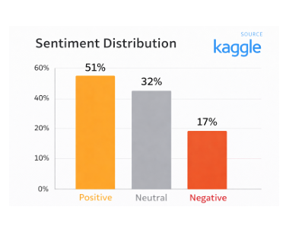
Figure 2. Sentiment distribution of the Kaggle Twitter dataset.

3.2. Dataset Cleaning and Preprocessing: Before the model training the unprocessed Twitter data went through multiple preprocessing steps to minimize noise and enhance overall data quality. These steps included the removal of URLs, user tags, hashtag symbols, numerical values, special characters, and extra whitespace. All text was converted to lowercase to keep the data consistent. Each tweet was divided into individual tokens using tokenization, and then removal of stopwords to remove significantly frequent but semantically neutral words. These preprocessing functions are useful in the reduction of data sparsity and promote the efficiency of the following feature extraction and model learning. The data preprocessing workflow is illustrated in Fig. 3. It breaks down the major stages involved in noise elimination, tokenization, normalization, and emoji handling, resulting in clean, normalized and filtered tweets suitable for feature extraction and sentiment classification.

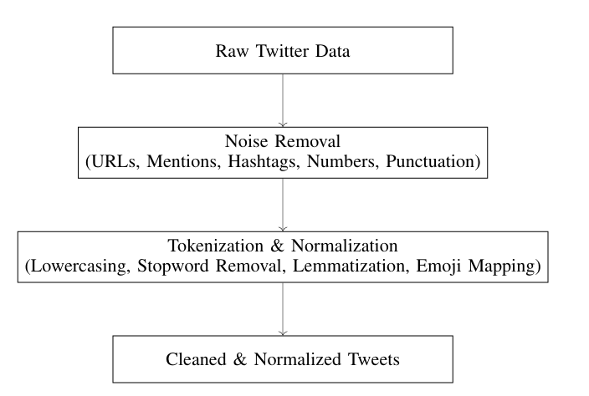
Figure 3. Data preprocessing pipeline for Twitter sentiment analysis.

3.3. Feature Extraction: There are two feature extraction techniques that were used in the case of the baseline and hybrid models. TF-IDFT is important because it was distributed across the frequency distribution to understand corpus, while Word2Vec embeddings were used for meaningful associations between words in a continuous vector space. TF-IDF features were mostly used with conventional machine learning models whereas Word2Vec embeddings were combined with deep learning models to incorporate contextual information. Transformer-based models such as BERTweet do not require the explicit feature extraction, as such they learn the contextual representations directly out of raw text.

3.4. Preparation of Data for Modeling: Upon cleaning the data and feature extraction, the data have been extracted, splitting that data into training and testing sets to see how well the model performs. Partitions were also constant between data via baseline, hybrid as well as for transformer-based models to ensure fair and sound comparison. This consistent data processing pipeline improves the reliability of the results and makes the experiments easier to reproduce.

4. METHODOLOGY
This describes the sentiment analysis strategy used in this study. It encompasses classical models of machine learning, hybrid approaches, deep learning strategies, transformer model and explainability features and based model. The overall workflow is illustrated in Fig. 1.

4.1 Traditional Machine Learning Models: The traditional learning models were considered to form the baseline classifiers due to their simplicity, computational complexity and interpretation. In order to enable such models to process textual data, tweets first were changed into numerical forms using Term Frequency Inverse Document frequency which assigns more weight to words should they be frequency repeated in the same tweet but not excessively repeated in all tweets. The TF-IDF value is calculated as

value(a, b)=frequency(a, b)×log(n/​n^{t}) (1)

where a denotes a term, b represents a tweet (document), frequency(a, b) is the frequency of term a in tweet b, n is the total number of tweets in the dataset, and n^{t} is the number of tweets containing the term a. The TF-IDF formulation in Eq. (1) follows the standard definition reported in [21] and tweets are good with it since they just highlight the words that are important and emphasize the common words that appear everywhere. This enhances easier interpretation of what a tweet means.
Three classical machine learning classifiers- Linear Regression, Multinomial Naive bayes, Support Vector Machine were tested as a reference model to sentiment analysis based on TF IDF features representations. These are usually used in the process of classifying text and are reliable as a standard of evaluating more complex methods.
A probabilistic classifier that was used in Linear Regression was to comprehend the connection between TF-IDF features and sentiment labels. The model assigns weights to individual features that estimate the likelihood of a tweet being contained in one sentiment category. Its straightforwardness and effectiveness establish it as a strong base of high dimensional text information.
Support Vector Machine was employed to create a perfect decision boundary among sentiment categories within the feature space. SVM is good in terms of max performance, reducing the distance between classes particularly handling with sparse representations like TF-IDF vectors.
Multinomial Naive Bayes was applied as a generative model that shows distribution of words of classes depending on the condition of independent features. Even with its simplicity this model remains computationally efficient and has no assumptions and often generates competitive results in sentiment analysis tasks.
These traditional classifiers used together establish baseline performance metrics, and it can be compared to hybrid and deep learning and transformer models discussed later in the study significantly.
4.2. Hybrid Models: To increase the representational ability and retain Two hybrid models have been investigated, which are computationally efficient.
1) Hybrid Model 1: TF-IDF + SVM: In the first hybrid approach, combination of TF-IDF features and an SVM was used to improve discrimination between sentiment classes. This model has the advantage of making use of statistically weighted features and margin-based classification, which is more effective than traditional models on their own.
2) Hybrid Model 2: Word2Vec + LSTM: The second hybrid approach merges Word2Vec embeddings with an LSTM network to understand both semantic temporal and causal relationships on tweets. Word2Vec encodes words as dense vectors that maintain semantic associations, which are processed in sequence by LSTM. The LSTM recognizes contextual and sentiment trends within the tweet Through the use of an internal memory that are frequently overlooked by feature based methods. This hybrid approach provides finer representation of sentiment as compared to conventional classifiers and at the same time computationally more efficient than transformer-based models.

4.3. Deep Learning Models: A separate LSTM-based deep learning system was also implemented directly to model the sequence of tweets representations. LSTM networks are capable of learning time dependence and their ability to handle long-range context information in tweets remains limited, motivating the use of models on the basis of transformers.

4.4. Transformer-Based Model: BERTweet: In order to gain more contextual insight, BERTweet, a model trained on large-scale Twitter based on transformers data, was refined in sentiment classification. BERTweet is based on the transformer architecture founded on representational models to express contextual relationships: self-attention mechanisms The model is built on the transformer framework and utilizes self-attention mechanisms to acquire contextual relationships between words in a sequence, enabling more accurate sentiment prediction [22], [25]. The self-attention operation employed by the transformer is defined as

$Attention(X,Y,Z) = softmax((XY^T)/sqrt(D_k)) Z$ (2)

where X, Y, and Z denote the query, key, and value matrices, respectively, and Dk represents the dimensional of the key vectors. Equation (2) follows the standard transformer self-attention formulation [22] and adopted by BERTweet for contextual representation learning [25]. This mechanism helps the model understand important relationships between words across the tweet. The final sentiment prediction is obtained using a soft max classifier Equation (3), which converts the model output scores into normalized class probabilities for multi-class sentiment classification [23]. The softmax-based probability estimation is given by
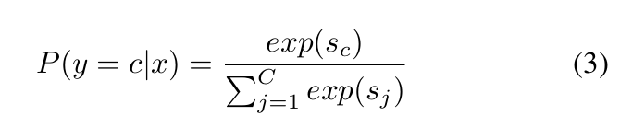
where C denotes the total number of sentiment classes and sc is the predicted score for the class c.

4.5. Explainable Artificial Intelligence Using SHAP: To enhance model transparency, Explainable Artificial Intelligence (XAI) was incorporated using SHAP, which interprets predictions through additive feature attributions derived from cooperative game theory [24]. The SHAP explanation model is defined as
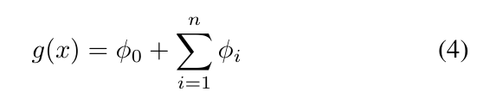
where g(x) denotes the model output, ϕ0 represents the base value, and ϕi indicates the contribution of the ith token. This formulation enables token-level interpretation of sentiment predictions and mitigates the black-box nature of transformer based models [24].
Fig. 4 illustrates the BERTweet-based sentiment analysis workflow, highlighting the major stages from preprocessing to explainable sentiment prediction.

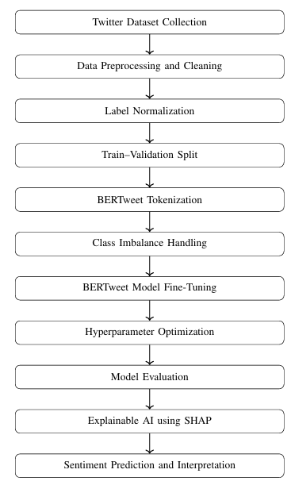
Figure 4. BERTweet-based sentiment analysis workflow with explainability.

5. RESULTS, EVALUATION, AND ERROR ANALYSIS

This part covers the experimental results obtained from conventional machine learning models, hybrid approaches, neural network models, along with a transformer-oriented sentiment analyzer. Standard classification measures are used to measure model performance so that it can be compared fairly and equally across all ways.

5.1. Evaluation Metrics: The performance of the sentiment classification models was measured using three standard metrics: Accuracy, Precision, and Recall, which are frequently employed in supervised classification assignments [23]. Precision assesses the overall accuracy of forecasts, Precision measures the ratio of accurately forecasted positive cases, while Recall assesses the capability of the model to recognize all pertinent positive instances. These metrics are defined as follows:

Accuracy = Total Predictions/Correct Predictions
Precision =​ True Positives/ True Positives+ False Positives
Recall = True Positives/ True Positives+ False Negatives

5.2. Model Performance Comparison: Table II shows the performance of each of the assessed models in terms of accuracy, precision, and recall. The BERTweet model has a good accuracy of 91.57. The findings indicate that the traditional machine learning models offer a high baseline in sentiment classification. Hybrid models also promote higher performance due to feature-based representations being integrated with learning-based approaches. The transformer-based BERTweet model of the examined approaches has the highest score in all metrics, which demonstrates the capabilities of the model to capture the intricate contextual and semantic features of Twitter data.
Model | Accuracy | Precision | Recall
Linear Regression | 84.2 | 83.6 | 82.9
Naïve Bayes | 82.5 | 81.9 | 81.2
SVM | 86.1 | 85.4 | 84.8
TF-IDF + SVM | 88.6 | 87.9 | 87.2
Word2Vec + LSTM | 89.3 | 88.7 | 88.1
LSTM | 87.4 | 86.8 | 86.1
BERTweet | 91.57 | 90.4 | 90.1

Table 2. COMPARISON OF SENTIMENT ANALYSIS MODEL PERFORMANCE.

5.3. Error Analysis: Despite the high overall performance, it was concluded that there are a number of sources of classification errors. Nonhybrid and hybrid models tended to misclassify tweets that had sarcasm, idiomatic words or phrases and sentiment that is highly reliant on context. The neutral tweets were also most challenging to categorize as they had a lexical overlap between the positive classes and the negative classes and were challenging to distinguish. Although the BERTweet model greatly minimized such errors, misclassifications in tweets whose sentiment was implicit or were written ambiguously did still take place. Explainability SHAP-based assisted in determining the essential tokens that led to misleading model predictions, offered valuable advice to the model, and allowed pointing out the trends to improve the model in the future. The confusion matrix of the BERTweet model is presented Fig. 5 the rows represent the actual sentiment categories, and the columns represent the categories where the model predicts the sentiment to be. The 0, 1, and 2 numbers represent negative, neutral, and positive classes, respectively.

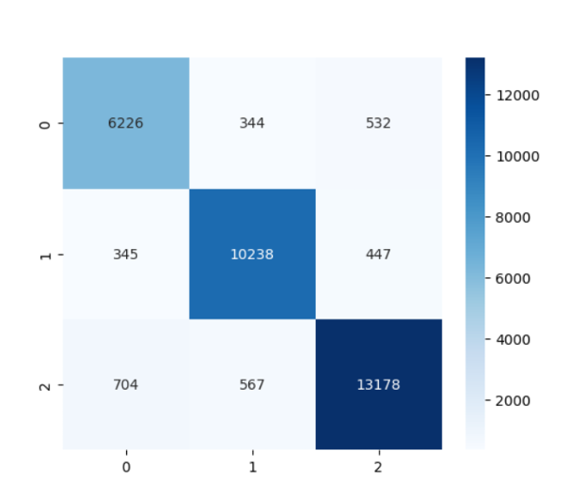
Figure5. Confusion table of BERTweet model that does three-class sentiment classification.

6. DISCUSSION
The findings of the experiment provided show that there is a clear distinction in the performance comparison of the traditional, hybrid, and transformer-based approaches to sentiment analysis and focus on their complexities. The paper analyzes the text in Twitter and explains the strengths and weaknesses of the two modeling approaches. The traditional machine learning models like Linear Regression, Naive Bayes, and SVM are useful but depend on manually and are limited by their reliance on manually constructed features, which restrict their ability to capture contextual and implicit sentiment that is generally found in tweets. Hybrid models show continuous improvements representation with feature-based representations using combinations, performance can be combined, learning-driven methods. TF-IDF + SVM and Word2Vec + LSTM obtain more balanced and more accurate comparative measurements of precision-recall to other traditional methods, pointing out the benefits of incorporating semantic data. How ever, these gains are small and this implies that hybrid models are still struggling with long-range context. Transformer-based model Bertweet performed best in terms of overall performance on all evaluation metrics since the model is pre-trained on huge amounts of Twitter data. Nevertheless, despite the high level of accuracy, the model continues to fail in its attempt to identify the neutral sentiment correctly, which is reflective of the inherent ambiguity of the social media language. The use of SHAP-based explainability as an additional means of strengthening the method also makes the sentiment analysis system more transparent and reliable as it shows the words that impact predictions.

8. CONCLUSION AND FUTURE WORK
This research investigated the sentiment analysis on Twitter utilizing a methodical evaluation of the traditional machine learning models, mixtures and as can be seen, the results reveal a gradual performance improvement the models shift to less complex lexical representations context aware methods of learning. Classifiers such as Linear regression, Naive Bayes and SVM are reliable as a baseline. They are, however, reliant on handcrafted features not only limit their ability to address the informal, situational nature of Twitter text. The hybrid models offer a sensible trade-off between representation and efficiency learning. The TF-IDF + SVM and Word2Vec + LSTM models provide more consistent and have better performance than conventional algorithms especially in high noise data environments. These gains notwithstanding, the improvements are moderate that show that hybrid models are yet to be fully realized in the representation of long-range dependencies and subtlety. sentiment changes that are common in twitters. The BERTweet model is based on a transformer. architecture, overall, attains the highest performance, with a maximum accuracy of 91.0. This is because of its effectiveness pretraining on Twitter data and its capability to pretrain on large scale data. contextual relationships based on self-attention. However, there are difficulties in using complex models’ transformers would bring interpretability. This shortcoming is overcome by using SHAP based explainability that gives out explicit token level understandings of behavior on predictions. On the whole the proposed framework creates an equilibrium between Making it well predictive performance and interpretability appropriate to real world sentiment analysis. Future works are able to investigate more successful approaches to neutral sentiment management class imbalance as well as extrapolating the framework to multilingual and cross-domain social media data.

References

[1] Y. Qi and Z. Shabrina, “Sentiment analysis using Twitter data: A com parative application of lexicon- and machine-learning-based approach,” Social Network Analysis and Mining, vol. 13, no. 1, pp. 1–15, Feb. 2023.
[2] M. K. Hassan, F. A. Hudaefi, and R. E. Caraka, “Mining netizen’s opinion on cryptocurrency: Sentiment analysis of Twitter data,” Studies in Economics and Finance, vol. 39, no. 3, pp. 365–384, 2022.
[3] S. Neelakandan, D. Paulraj, P. Ezhumalai, and M. Prakash, “A deep learning modified neural network (DLMNN) based proficient sentiment analysis technique on Twitter data,” Journal of Experimental & Theo retical Artificial Intelligence, vol. 36, no. 3, pp. 1–18, 2024.
[4] P. Rita, N. Ant´onio, and A. P. Afonso, “Social media discourse and voting decisions influence: Sentiment analysis in tweets during an electoral period,” Social Network Analysis and Mining, vol. 13, no. 1, pp. 1–19, Mar. 2023.
[5] B. AlBadani, R. Shi, and J. Dong, “A novel machine learning approach for sentiment analysis on Twitter incorporating the universal language model fine-tuning and SVM,” Applied System Innovation, vol. 5, no. 1, pp. 1–15, Jan. 2022.
[6] M. S. Amin et al., “Harmonizing macro-financial factors and Twitter sentiment analysis in forecasting stock market trends,” Journal of Computer Science and Technology Studies, Jan. 2024.
[7] E. Lee, F. Rustam, P. B. Washington, F. El Barakaz, W. Aljedaani, and I. Ashraf, “Racism detection by analyzing differential opinions through sentiment analysis of tweets using stacked ensemble GCR-NN model,” IEEE Access, vol. 10, pp. 10234–10247, 2022.
[8] B. Andrian, T. Simanungkalit, I. Budi, and A. F. Wicaksono, “Sentiment analysis on customer satisfaction of digital banking in Indonesia,” Faculty of Computer Science, University of Indonesia, vol. 13, no. 3, 2022.
[9] A. Bello, S.-C. Ng, and M.-F. Leung, “A BERT framework for sentiment analysis of tweets,” Sensors, vol. 23, no. 1, pp. 1–18, Jan. 2023.
[10] S. Bengesi, T. Oladunni, R. Olusegun, and H. Audu, “A machine learning sentiment analysis on Monkeypox outbreak: An extensive dataset to show the polarity of public opinion from Twitter tweets,” IEEE Access, vol. 11, pp. 1–15, Feb. 2023.
[11] N. Garg and K. Sharma, “Text pre-processing of multilingual for sentiment analysis based on social network data,” International Journal of Electrical and Computer Engineering, vol. 12, no. 1, pp. 1–10, Feb. 2022.
[12] A. R. and A. A., “Arabic tweets-based sentiment analysis to investigate the impact of COVID-19 in KSA: A deep learning approach,” Big Data and Cognitive Computing, vol. 7, no. 1, pp. 1–16, Jan. 2023.
[13] M. A. Palomino and F. Aider, “Evaluating the effectiveness of text pre processing in sentiment analysis,” Applied Sciences, vol. 12, no. 17, pp. 1–19, Aug. 2022.
[14] K. L. Tan, C. P. Lee, K. S. M. Anbananthen, and K. M. Lim, “RoBERTa LSTM: A hybrid model for sentiment analysis with transformer and recurrent neural network,” IEEE Access, vol. 10, pp. 20456–20469, 2022.
[15] M. S. U. Miah et al., “A multimodal approach to cross-lingual sentiment analysis with ensemble of transformer and LLM,” Scientific Reports, vol. 14, pp. 1–16, Apr. 2024.
[16] K. L. Tan, C. P. Lee, and K. M. Lim, “RoBERTa-GRU: A hybrid deep learning model for enhanced sentiment analysis,” Applied Sciences, vol. 13, no. 6, pp. 1–18, Mar. 2023.
[17] M. Boukabous and M. Azizi, “Crime prediction using a hybrid senti ment analysis approach based on bidirectional encoder representations from transformers,” Indonesian Journal of Electrical Engineering and Computer Science, vol. 25, no. 2, pp. 1–12, Feb. 2022.
[18] F. Barbieri, L. Espinosa-Anke, and J. Camacho-Collados, “XLM-T: Multilingual language models in Twitter for sentiment analysis and beyond,” in Proc. Language Resources and Evaluation Conf. (LREC), 2022, pp. 258–266.
[19] A. P. Rodrigues et al., “Real-time Twitter spam detection and sen timent analysis using machine learning and deep learning techniques (retracted),” Computational Intelligence and Neuroscience, 2022.
[20] H. T. and M. M., “Artificial intelligence and sentiment analysis: A review in competitive research,” Computers, vol. 12, no. 2, pp. 1–20, Feb. 2023.
[21] A. Kumar, S. Verma, and R. Singh, “TF-IDF based text representation for sentiment classification,” IEEE Access, 2022.
[22] A. Vaswani et al., “Attention is all you need,” in Advances in Neural Information Processing Systems (NeurIPS), 2017, pp. 5998–6008.
[23] C. M. Bishop, Pattern Recognition and Machine Learning. New York, NY, USA: Springer, 2006.
[24] S. M. Lundberg and S.-I. Lee, “A unified approach to interpreting model predictions,” in Advances in Neural Information Processing Systems (NeurIPS), 2017, pp. 4765–4774.
[25] D. Q. Nguyen, T. Vu, and A. T. Nguyen, “BERTweet: A pre-trained lan guage model for English tweets,” in Proceedings of the 2020 Conference on Empirical Methods in Natural Language Processing (EMNLP), 2020, pp. 9–

